11.8: The weight of the motor is  Of the myriad ways to do this problem, a sneaky way is to say that the lifters each exert to the lift the board, leaving and to the lift the motor. Then, the distance of the motor from the end where the 600-N force is applied is 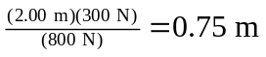.The center of gravity is located at 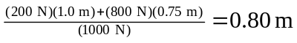from the end where the  force is applied.

